3 How to Save to an MP4 Movie Clip
This will be a short and sweet tutorial on how we can save this to an MP4 movie clip. We have our dancers masked out and the new background in. Now, we just need to save it.

The Deliver Tab
At the very end of the tabs at the bottom of the App, is a Deliver tab. Looks like a spaceship.

This shows up in a panel on the left side and not in the right.
1. Choose Your Export Preset:
- On the left side, look for "Render Settings"
2. Choose Save Location:
- At the top, you'll see "Filename" and "Location"
- Click "Browse" to choose where to save your MP4
- Give it a name like: "Walz_Background_Replaced.mp4"
3. Format and Codec
- Under "Format", select MP4
- Under "Codec", select H.264 (best compatibility with CapCut)
4. Quick Settings to Check:
- Resolution: Should match your timeline (1920x1080 or whatever you're using)
Click File (top menu)
Click Project Settings
Look at the Timeline Resolution section
You'll see something like: 1920 x 1080 HD or 3840 x 2160 4K, etc.
Note the resolution and frame rate (like 24fps, 30fps, 60fps)

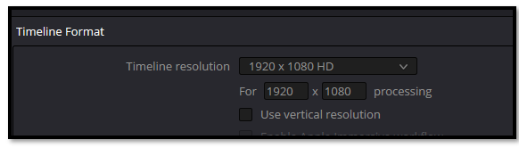

- Frame Rate: Match your timeline frame rate. (CapCut had 30 fps found under details at right)
- Quality:
  - Move the "Quality" slider to "Restrict to" around 15-20 Mbps for good quality
  - Or use "Automatic" if available
5. Render:
- Click "Add to Render Queue" button (bottom right)
- Then click "Render All" button
It will process and create your MP4 file!
Enter your Save info here, and all the rest of it, it told you to do from the above list.
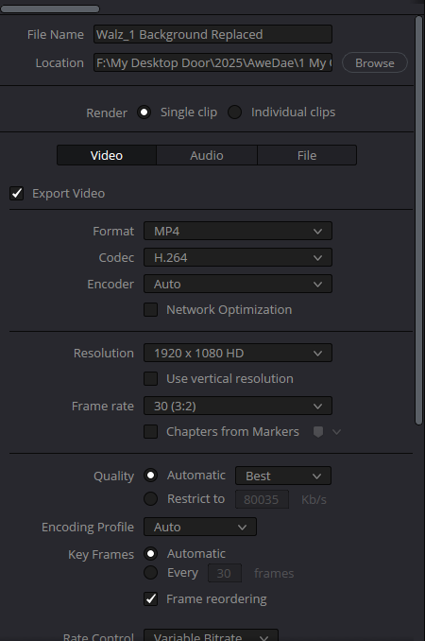

Add to Render Queue, button at bottom to start rendering.
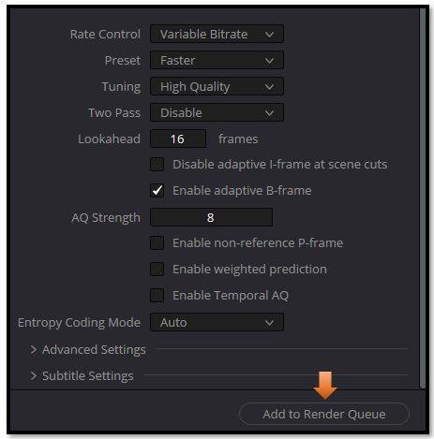
It will show your job top-right. This one is Completed.
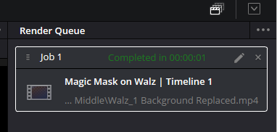
You must Click this button, under that box “Render All” to Start. You will find this button under job1.
